**NHMRC : National Australian Research Grants Interactive Data Visualization**

Randi Mendel

**The Data: NHMRC Research Grants**

Data Source: <https://www.nhmrc.gov.au/grants-funding/research-funding-statistics-and-data>

This is where I received my dataset on funding for Research in Australia, which has all been compiled over years of projects, including a number of aspects of each of these projects that has been gathered. I chose to focus in on an interesting aspect of this data that I was curious about – what institutions were running these research projects, which is the “sector” in this dataset.

Based on the vast number of research projects that exist in this dataset, and the overwhelming amount of information, plotting all projects has a rich amount of information to start with, however there are some interesting trends here to be explored, which is why I wanted to begin by plotting all these projects by budget, but also offer the option to filter down the amount of data being selected. As you can see in my initial draft of the visualization, in addition to showing a point for each project, encoded by coloring each section, given that this was overwhelming to actually analyze each sector, I chose to use a bar chart to most easily compare the budgets that were allotted to research projectstaking place at each given type of institution, which is given by the Sector on the x-axis of the bar chart in my final visualization.

**Part 1**

This was my storyboard of what I planned my visualization to look like 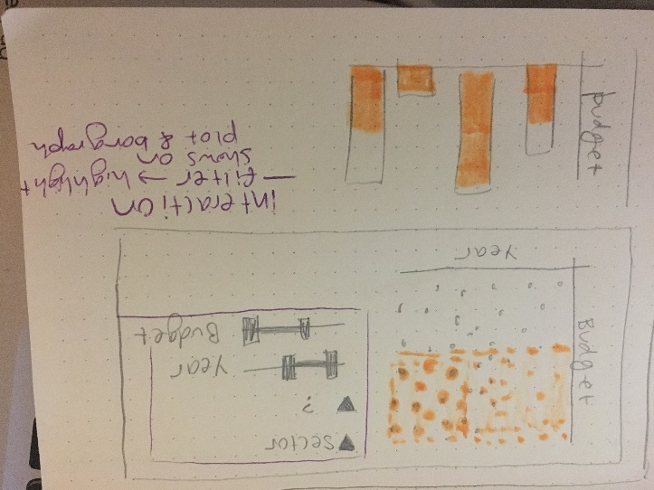when a range of values were selected with the sliders on the right. I wanted to show all the data, but have the selected region highlighted that fits in the filters.

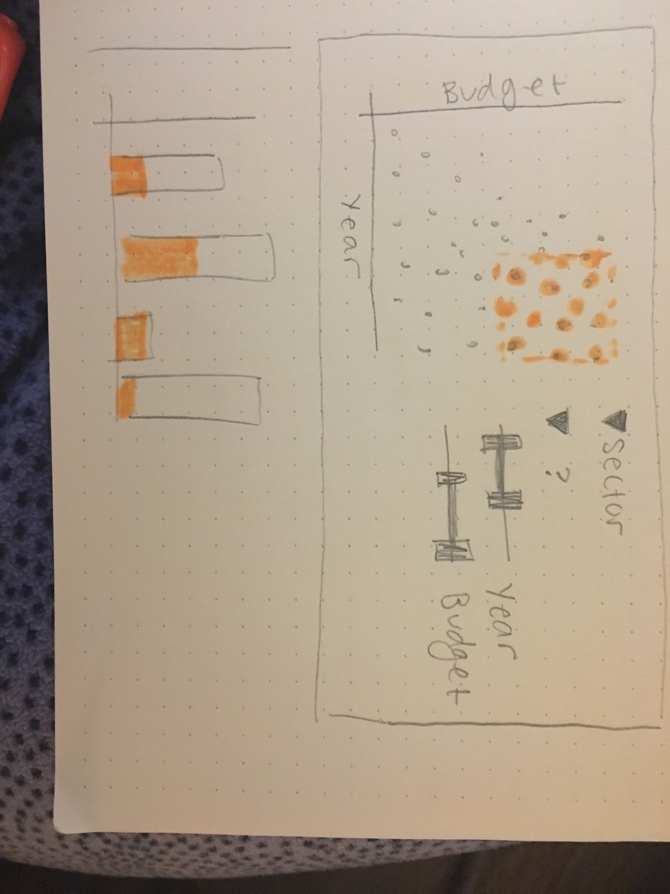

As seen in the second image, when a larger region of years is selected, the highlighted region would be distributed farther along the x axis, which would also be mirrored on the bar chart, which shows that portion of the total budget is covered by the highlighted area.

Data Displayed:

* Project as a point on the scatter plot, showing the year of the project and the budget for that project encoded by the location of that point on the graph
* Budget totals by sector that hosts the research, which is linked to the selected project
* Filter by sector in plot and select particular range

Part 1 Interactions:

* Highlighting by range selection
* Filter by dropdown options
* I did not draw this on the storyboard, however I also wanted to be able to show the transition from the application year 🡪 start year 🡪 end year, by moving the points on the graph to a new position on the x axis

**My Implementation of the Data Visualization**

I chose to demonstrate the data in the same form as my storyboard, with a scatterplot of the data with year by grant budget for each project, along with a bar chart of the total budget for a full sector, however there are a few differences in the interaction with this data from my original plan, based on further exploration of both natural associations made by a user, along with other aspects that made more sense or became clear upon building the visualization in d3. The implementations of interaction, along with the reasoning for these choices are as follows:

* Filter by sector: This dropdown allows the user to view any sector by itself on the plot of the projects, in order to compare the distributions, which removing some of the information that might crowd the visual.
* Filter by Open/Closed: This dropdown allows the user to look at projects that are still open, vs those that are closed, and have already ended. There is a slight implementation issue with this feature, that it is losing a portion of the data, especially noticeable in the
* Select Year Animation: There is button available to select the year to display on the x-axis of this visualization by application, start year, or end year. This animated between these phases in order to allow one to see the length of particular projects and even visually compare projects by the amount of time (represented by displacement in the x direction) of the points.
* Brushing: I implemented this in a different way that my original intention of filtering. I had originally planned to select ranges by highlighting, however given the detail of this data, once learning more about brushing, I chose to implement domain and range selection in a different way for a number of reasons, as follows: (1) a user clicking and dragging on the image gives them a better visual idea of the range that they are choosing for quick exploration. (2) They get to zoom into that region in order to see more detail on those data points, this cannot be done by just highlighting the region, since the points will still be small, causing significant occlusion.

**Part 2**

Feedback